

Harbor Electronic Publishing

84 Mount Misery Dr • Sag Harbor NY 11963 • 631 725 9513

*HEPDigital.com* • *Sales@HEPdigital.com*

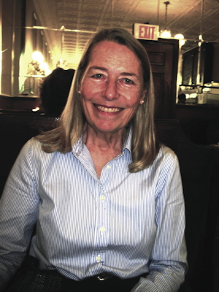

# About the Author, Alexandra Eames

Alexandra Eames, author, bought an 1894 Sag Harbor house with her husband Chris Leonard in 1977. An interior designer, she also wrote for a local newspaper, published several books on design, and styled interiors for magazines. A founding member of the Sag Harbor Historical Society she worked on the extension of the local historic district, is a member of the board of Mashashimuet Park and the Sag Harbor Tree Fund. Now retired, she spends most of her time in Sag Harbor with trips to Vermont where she and her husband are restoring a 200-year-old Federal brick house.

# About the Artist, Whitney Hansen

Whitney Hansen, artist, came to Sag Harbor in 1965. Her subjects are varied, from still life and portrait to seascapes and landscapes. The medium is oil and makes use of the woodcut process on textured rice paper. After the print is pulled, the surface detail is hand-painted in oil. Her works are in the collections of the Metropolitan Museum of Art, New York, the Scripps College Museum in Claremont, CA, and the Bowdoin College Museum in Brunswick, ME.

More info, graphics, samples: HEPdigital.com/press.html