

Harbor Electronic Publishing

84 Mount Misery Dr • Sag Harbor NY 11963 • 631 725 9513

*HEPDigital.com* • *Sales@HEPdigital.com*

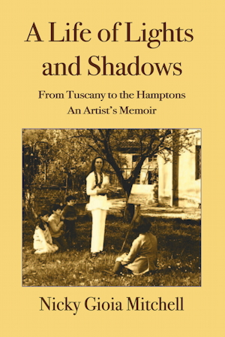

For immediate release: new publication

*A Life of Lights and Shadows:*

*From Tuscany to the Hamptons,   
An Artist’s Memoir.*

Nicky Gioia Mitchell

Nicky Gioia was born in the thirties in the historic villa Torre a Cona near Florence in Tuscany. She was destined to live a remarkably eventful life.

At an early age she endured the privations, traumas, and tragedies of World War II. While still a young woman, her first marriage ended with the untimely death of her beloved husband, Carlo, Marchese Pes di Villamarina del Campo. Years later she married Craig Knowlton Mitchell, an American socialite and sportsman. Throughout, she travelled the world meeting a variety of famous and interesting people.

Nicky Gioia Mitchell is a Hamptons artist well known for her landscapes and paintings of the beaches and ocean near her home. Her work has brought her much success. She has had 32 one-woman exhibitions in France, Belgium, Italy, Canada, and the United States—particularly in New York City.

This is her vivid memoir of a rich and colorful life.

130 pp, 75 illustrations, paperback: $40

Publication Date July 17

More info: James Monaco [jim@peconic.org](mailto:jim@peconic.org)

Graphics and Samples: HEPdigital.com/press.html