

Harbor Electronic Publishing

84 Mount Misery Dr • Sag Harbor NY 11963 • 631 725 9513

*HEPDigital.com* • *Sales@HEPdigital.com*

On Montauk: A Literary Celebration

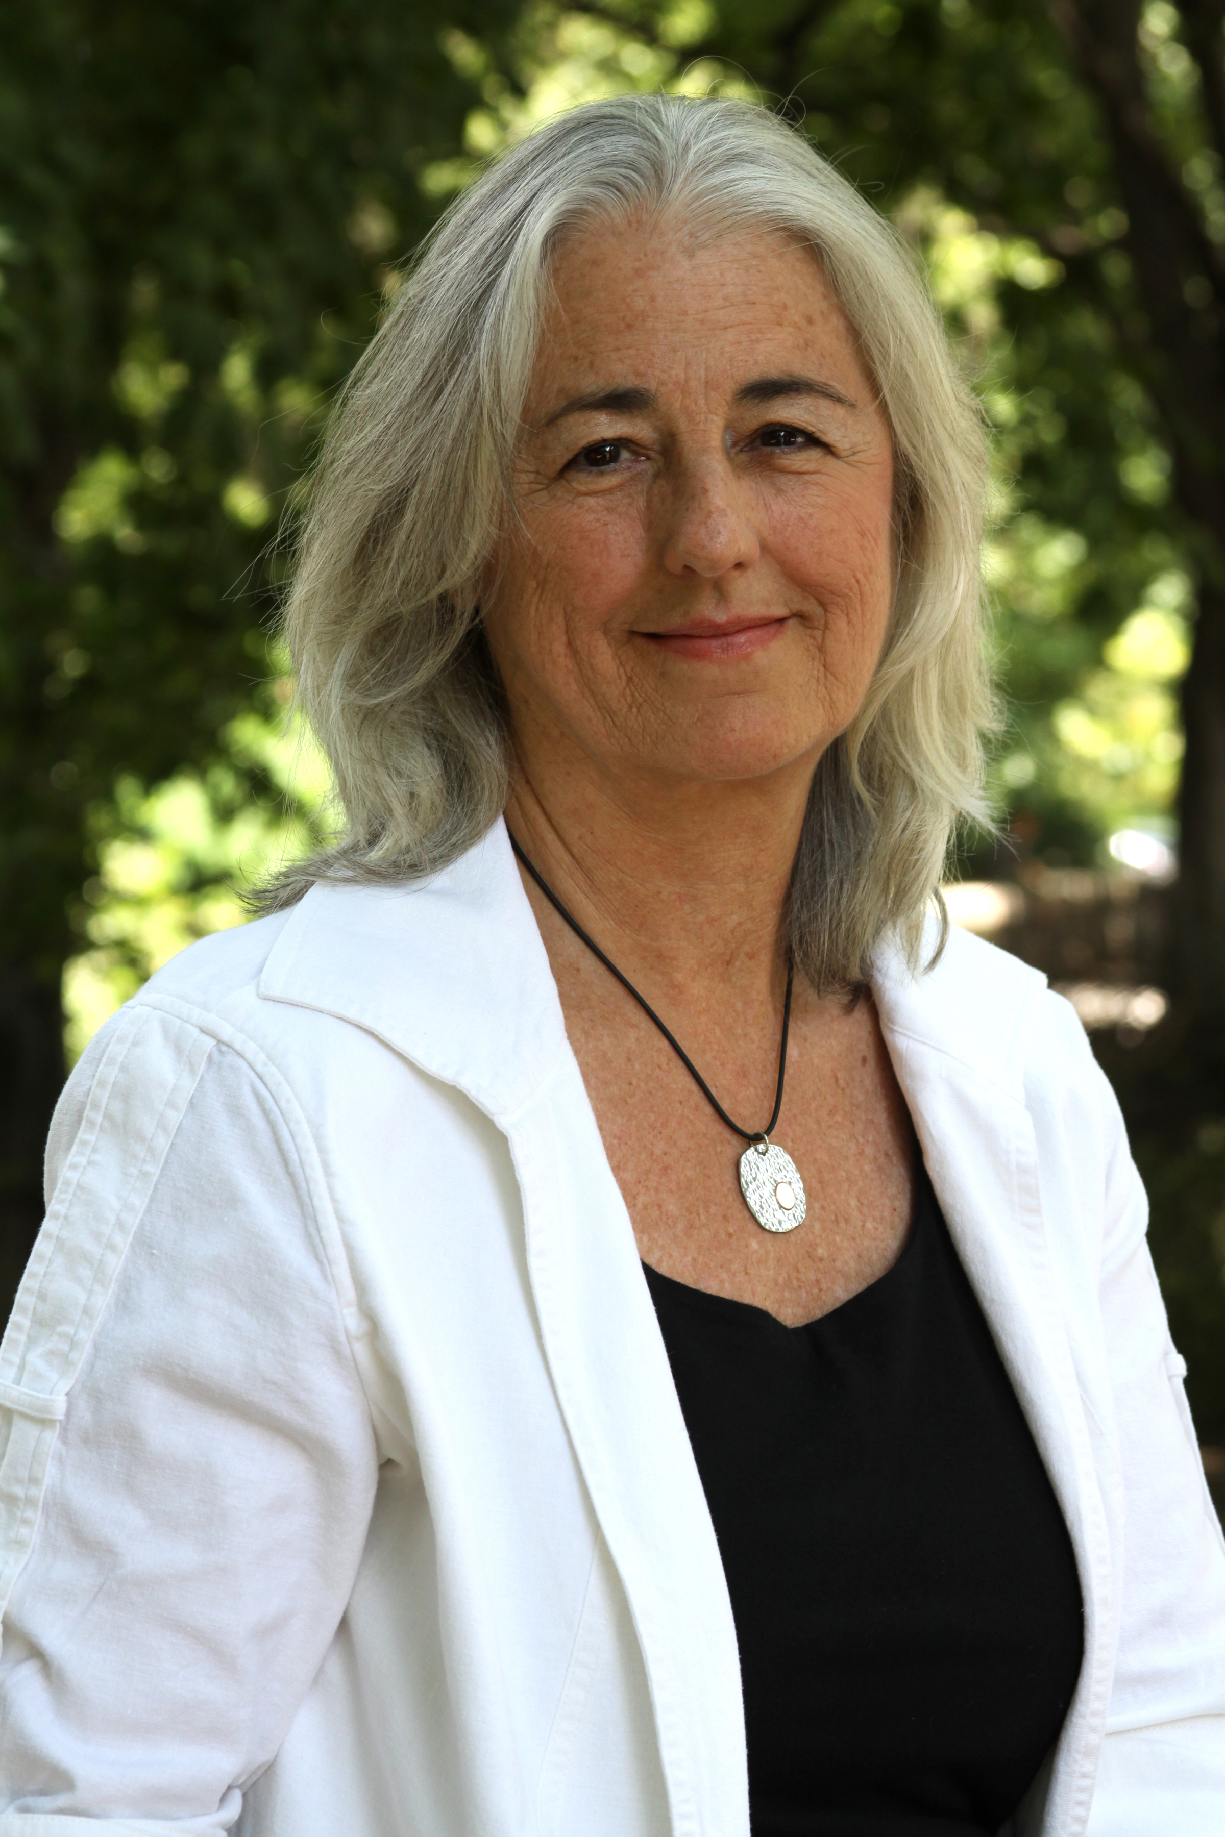

Céline Keating

Céline Keating lives in Montauk and New York City and serves on the board of Concerned Citizens of Montauk. She is the author of two novels, *Layla* (2011) and *Play for Me* (2015), an Indie Excellence Award finalist and a USA Book Award finalist. Her short fiction, nonfiction, and music journalism have been widely published.

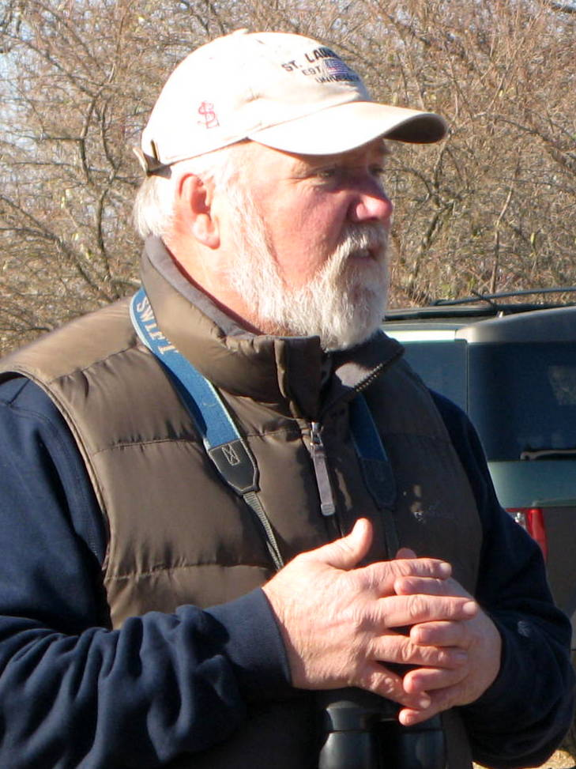

Ed Johann

Ed Johann has lived in Montauk for over thirty years. He is a board member of Third House Nature Center, Inc. and a founding member of the Montauk Writers’ Group.